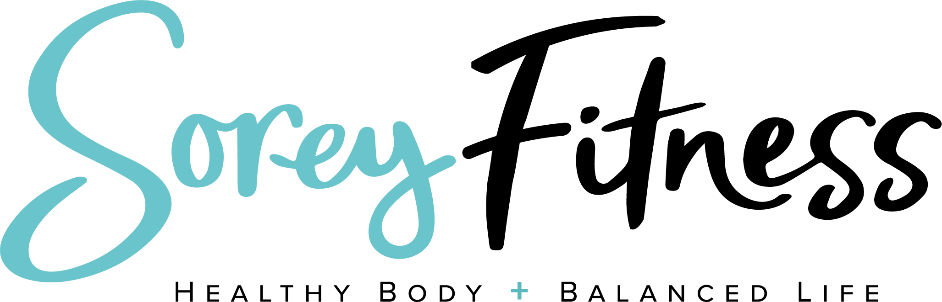 SAMPLE MEAL PLAN
Week 1 | Breakfast | Snack | Lunch | Snack | Dinner | 100-200 Calorie Treat
Monday | Monday Morning Breakfast | Greek yogurt; berries | Shakeology with milk | 12 Almonds | Stuffed Potato w yogurt cheese chopped chicken
Tuesday | Greek Yogurt with berries (170) | Shakeology w/ 1/2 orange | ½ Wrap w hummus, turkey, tomato, avocado & feta | 2 Hardboiled Eggs & Tomato | 1/2 sweet potato with 1 cup cooked spinach & 4oz Chicken
Wednesday | 2 eggs, onions, spinach & tomato on toast | 1 cup Edamame | ½ Ezekiel wrap with nut butter & banana | Orange & 12 almonds | Chicken Soup with Butternut Squash
Thursday | Cream of Wheat, flax, wheat germ, bee pollen, & egg whites, cinnamon | 12 Walnuts | 6oz can of tuna on bread with cheese, tomato, onion, lettuce and mustard | 1 Cup Greek Yogurt | 4 oz grilled chicken 1/2 cup potato and 1 cup broccoli
Friday | ½ Ezekiel wrap with nut butter & banana | ½ apple or banana with nut butter | Amy's Black Bean Soup (Store Bought) | 1 Scoop Shakeology 1 cup strawberries | 4 oz flank steak 1/2 cup mashed sweet potato 1 cup fresh asparagus
Saturday | 2 Eggs 1 cup spinach, 2 tbsp walnuts | 1 Small apple 2 tsp almond butter | 4 oz salmon 1Cup veggies, 1/2Cup Edamame, 1Tbsp oil-based dressing, 2Tbsp nuts | 1 Scoop Shakeology 1/2 banana | 4 oz grilled chicken 1/2 cup potato and 1 cup broccoli
Sunday | 3/4 C Greek Yogurt, 1C berries, 2 tbsp walnuts | 1C celery sticks 2 tsp pb butter | Salad with Chicken | 1 Scoop Shakeology 1C berries | Chili and baked potato
*We’re not registered dieticians. You should always consult your doctor before starting any plan. This is just a personal meal plan.

